UNFOLDING THE SERVICE
Implementing a Participative Nomadic Restoration Vehicle Service
for Empowerment of the Communities
Evren Uzer
PhD Candidate in ITU Urban and Regional Planning Department, Istanbul, working with Disasters, Participation and Urban Design.
uzere@itu.edu.tr

Otto von Busch
PhD Candidate at HDK, Gothenburg, working with Methodologies for Applied Social and Subversive Design.
otto@kulturservern.se

Historical city centers are threatened both by the structural weaknesses came by time and changes occur via physical, social transformations in the surrounding. Historical buildings located in the central areas which are having poor conditions are habited by low income habitants whom have different priorities. These buildings suffer from lack of even the basic maintenance. Low-income people who are living in these historical buildings with various backgrounds, cultural specialties, usage behavior and the condition, legal status of these buildings (ownership etc.) require a focused search and study in these areas. For keeping the houses from falling apart, especially in places where all the maintenance and restoration processes of private property are not carried by (or not having a total subvention from) the government becomes an issue which requires some practical solutions. Poverty which is one of the primary reasons of being this much protected is also the reason for deterioration. When the market sees these deteriorated inner city historical areas profitable, land value rises with the newcomers/entrepreneurs and a gentrification process starts. In the 1980’s and onwards in all over the world commercializing and/or marketing the historical buildings and sites mostly seem to be the easiest and most practical solution to “save” those areas (Hobson, 2004). Tourism and tourists became the target customers. Most of the new urban renewal projects aim to revitalize these areas which are experiencing a slow deterioration process by suggesting fashionable tourist services. Thus the ambiguity of heritage areas losing their “atmosphere” as they are “saved”.
This project is a cross-over design task and practical exploration of possibilities and design of an itinerant vehicle, which aims to establish possible solutions for increasing the life quality by supporting local communities, in the deteriorated inner city areas which in some cases have historical value as well. This support includes providing the inhabitants technical assistance, training, material and tools via itinerant vehicle. Main aim is to establish a process model based on NOREV (Nomadic Restoration Vehicle) to search for its possible contribution for the areas where people have different priorities than repairing and painting their houses, which would have a dramatic affect in long term for the housing structures. Seeing the existing tenants as the target population and cultural heritage as a sustainable source for the cities, this project study seeks for practical solutions for the areas which can be defined as deteriorated historical wooden houses used as low-income housing.
As a unique functioning example of participative housing in a First World Country, Oranssi in Helsinki-Finland has been taken as a basis for Nomadic Restoration Vehicle Process. Evaluation of the possible scenario of NOREV processes are based on individual and group meetings with people who took part in Oranssi experience in different levels and/or people who are working on Oranssi experience.
This stage of the project does not aim at final construction the vehicle, but aims to raise the concerns and interest of the involved partners and lowering the threshold for its construction if these same partners find a common ground for collaboration… (There is no direct need in Helsinki, thus we hope to produce a toolbox and manual for local groups, but also municipalities, in the Baltic region to anchor the project firmly into a sustainable and relevant service according to their specific needs)

Oranssi as a functioning participation system
Active participation in projects of housing and planning mostly aim for new housing areas in Third World Countries within the framework of empowerment studies. In developed countries and for existing housing areas participation is generally limited with the contribution of the residents in the ideas level to the planning and the design process and also financial issues in some cases. Taking civic participation into consideration is seen as a success of the plan which is increasing the quality and level of democracy within the process whereas it’s seen as an issue prolonging the process in many cases. Examples of participation in means of labor are generally seen as a developing countries’ solution in which the governments cannot give technical support or provide housing directly. With technical assistance from the professionals tenants build their own houses themselves. The nearest example to that in developed countries can be co-housing development and/or participatory communities where you share the space and decisions about using the space and sometimes the income and the costs as well.
Oranssi as an activist group, established by young people who are in need of low rent houses, started in 1990 by squatting the empty houses belonging the City of Helsinki which the government was keeping empty for future development. They had tense times with the police who were getting them out by force after 2-3 days of squatting the places. They acted passive and didn’t use force against police. After those confrontations the group changed to a more constructive attitude and established a firm – Housing Company (owned by the Oranssi association)-, in 1992 to have a stronger voice when negotiating with the City of Helsinki and also to be able to take loan from the banks to renovate the old wooden houses for living. In the summer of 1992, Oranssi took over an old taxi drivers’ garage, which was turned into a youth house by young volunteers. After long negotiations, the city of Helsinki rented to the Oranssi association two old wooden houses in the Kumpula area, which were going to be demolished. Oranssi members began to work on Intiankatu houses’ renovation themselves with some financial support from the Finnish Slot Machine Association and a bank loan which they get over the firm. The first renovation took 6 months starting from April 1992 but they ran out of money to complete the minor construction like fixing the water pipes. The habitants accepted to begin to pay the rent before the renovation was completed so that Oranssi could continue the work with the money coming from the rent.
After this first successful attempt, the following negotiations went easier with the city government. The independent renovation projects have slowly improved during the 1990s and new projects have been taken on. Today they have 75 apartments and 120 tenants living in those apartments. Some of the houses are under protection and the construction works are going with the consultancy of the City Museum.
Oranssi firm still continues to renovate houses which the City of Helsinki is offering them for renovation. They usually get the houses that City of Helsinki offers them but in some cases they asked for specific houses. Some of the houses are rented from the City of Helsinki and some of them are directly bought, depending on the current situation of the house. But the general tendency of the City of Helsinki is to sell the houses completely to Oranssi. Therefore the City of Helsinki facilitates the process as much as they can.
Oranssi is based in a former kindergarten building in Herttoniemi since 2003 and has a theater, a café and common use spaces and serving as a youth house that hosts concerts and performances. There is no age limitation for entering the centre therefore they don’t serve alcohol. They also host activist groups within the Helsinki region, in different cases, for concerts, activities, self defense courses, cooking and selling food etc.
Oranssi structure
For its housing projects, Oranssi chooses old wooden houses in poor condition which suit with their objectives of preserving cityscapes and promoting communal living. Communal living and tenants' participation in forming their own living environment is what distinguishes this active approach to housing apart from the more traditional approach. Oranssi aims to establish a communal and environmentally friendly model within a minimum cost, for renovation of the houses and provides an alternative supply for low rent housing. Tenants decide about their environment via a board of tenants from maintenance to the new applicants for new Oranssi houses. Oranssi firm has three full time employees; a project supervisor, a foreman and an architect. Foreman and the architect are also acting as housing technicians. Oranssi sometimes hires part time workers for complicated techniques and systems and uses the renovation processes as workshops for inhabitants to learn about renovation and reconstruction techniques.
Whenever there is a new Oranssi house the firm announces via web and Oranssi youth centre in Herttoniemi and collects the applications. They have two main priorities in selections; being between 15 and 25 years of age and of urgent need of housing. After a basic selection based on these criterion, Oranssi sends the applications to tenants’ board which decides who’ll have the flat. Most of the current tenants are Finnish; only 5% is from different ethnic backgrounds. They don’t have any criteria of eligibility about the background.
The Oranssi houses are very popular because of offering half of the average rent in Helsinki (6 €/m²), at a recent announcement they have received 80 applications for one apartment. Since 1992 they raised the rent only twice, in small amounts. After a tenant enters an Oranssi house he/she can stay as long as he/she wants. Mostly people only move out if they want a bigger space for example after having children. Oranssi houses are varying between 30-60 m², composed of 1, 2 or 3 rooms, a kitchen and a toilet, which have different spatial organization depending on the existing structure. They prefer not to put showers in the apartments for avoiding leaking and moisture problems in the future. Every house has a common sauna and a shower in the basement instead. Once a year, technical staff makes a general inspection and determines the priorities for general maintenance. Each house also has a workshop in the basement where the tenants can do their repairment work by themselves at anytime. They can also contribute financially if they want something extra than the basic needs. Presently, new renovation projects are financed through a renovation loan from the city of Helsinki. Additionally, the Finnish Slot Machine Association (RAY) has occasionally provided financial grants, as has the Ministry of Education.
Ministry of Environment also used one of the Oranssi houses to make an experiment on solar heating system by implementing panels to one of the houses. This experiment, which is overlapping with the Oranssi’s ideology of ecological solutions, is one of the examples of activities which both sides are benefiting. Oranssi also encourages organic farming in the back or front greenery of the houses and published an eco-guide book on consumption. They have ongoing discussions on expanding Oranssi but to stay in a manageable size. On the other hand they are looking for some solutions for low rent housing problem in Helsinki. They recently made a proposal to Ministry of Development for building new houses and prepared some plans for it, negotiations are ongoing.

Oranssi in context of empowerment
Among the activist groups in Helsinki Oranssi is having a unique position where the organization is performing an activity of applied discussion, acting as an example of parallel and manifested counter culture. Without loosing too much impetus or force when being institutionalized, the organization is still moving forward, expanding and evaluating its methodology.
What If Oranssi was Mobile? Or Is Nomadic Restoration Vehicle Possible?
As a functioning system, Oranssi can be basis for creating an empowerment tool or designing a system for the existing inner city housing areas, which in some cases have more poverty comparing to edge city slums. Idea of establishing a itinerant vehicle instead of a fixed organizational center is based on;
- to provide equal access to the service of technical assistance and training,
- to be small and less bureaucratic within the process as much as possible,
- to provide flat hierarchy, practical solutions with less structural costs,
- to empower the communities in their place in their structure and
- by being based on a local community to focus in means of labor, resource and targeted aims and population.

As we proceed in discussing the further stages of NOREV we have seen the constraints and the advantages which may vary in different scenarios for different local groups. These constraints and advantages could be put in balance with local reorganization of the possible process within the local systems. Each settlement, each neighborhood requires a ‘localized adjustment’ in detail.

Key actors
Inhabitants: Who are willing to change something with their contribution and eager to reach consensus, -Houses should participate to/ benefit from this service altogether preferably.-
Local NGO: Patient and capable to define and to carry on the physical, economic and organizational levels of the whole process. Small group of 4-6 people, including NOREV crew.
Public Sector: Central and Local Government Representatives which vary according to each place that will take place in decision of place, consultancy and legal issues related to advance changes. Institutions like; city planning office, municipalities, (when there are cultural heritage) conservation board and/or city museum, etc are counted under this title.
Private Sector: Construction and/or construction material companies which can provide cheap or for free material to the NOREV group, for tax reduction, for advertisement or for governmental subvention, etc.

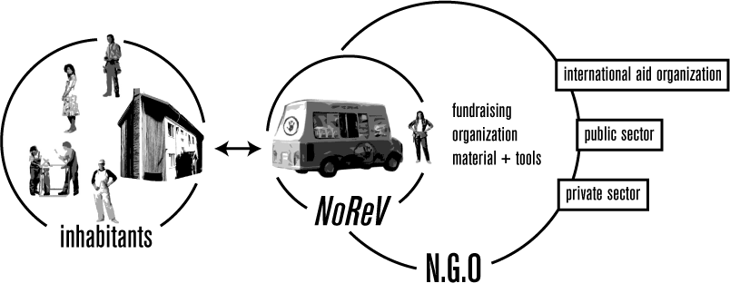
figure1: Basic Organization

Process
Process is traced from two main key actors’ perspectives, starting from the earliest starting, in order to understand the general scheme.

Process of Local NGO
Establishing the project for empowerment, common decision making process with the City Local government. This stage aims to eliminate possibility to choose an area which will confront a change of usage according to city plan and also cooperation in deciding the area and also may facilitate public sector as a resource provider (in financial, logistics or in other direct and indirect means)
Outcome and following preparation: Collaboratively chosen target area, preparation of information sheets and inquiries for understanding the structure of the population and the possible needs. Information sheets are involving both house and apartments specifications and needs and the skill specifications of the users.

Informing the target area/neighborhood residents about the service and its way of establishment. With the information material also there will be inquiry sheets delivered for the houses which are interested in receiving such a service.
Outcome and following preparation: Gathering the filled information sheets the interested households and evaluating the data

Sending NOREV to the sites for preliminary inspection. NOREV crew who will be composed of two technicians/technical staff (architect/ construction worker, electrician/plumber/carpenter) will evaluate the actual needs and the needs declared and time scheduling to make a realistic project program.
Outcome and following preparation: Necessary information for project structuring will be provided with the collaboration of the residents.

Project structuring according to the defined needs of participating residents.
Repair work will be basically separated into two according to Summer and Winter work (exterior and interior work for the structures) According to the season, resources and needs actual work lists will be formed. Provision of basic to complicated construction tools will be provided accordingly.

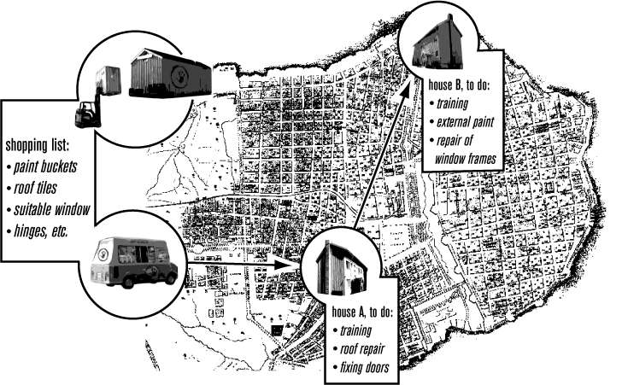
figure2: Process

In this phase all work should be organized in a balance with the resources and needs.
Outcome and following preparation: Detailed work lists and the locations are prepared by the Local NGO group and NOREV crew for a successful application process.

Publishing and distributing a simple newsletter periodically which is announcing the buildings taking NOREV service and the details of the work in order to provide transparency and avoid unreal rumors which may hurt the application process.

Starting the work according to the schedule. Initial work is to give the training of the aimed work type to the inhabitants and leave the necessary tools and material for a week to them. A common work list should be prepared by the inhabitants and the crew, which should have been prepared as a draft according to the primary information sheets and technicians evaluation.
Outcome and following preparation: Every application process –problems and unforeseen needs- will be reported to gain the feedback.

Periodic visits to the site After the initial training in order to distribute new materials to control and assist the ongoing process periodically -every week in the same day-NOREV will be visiting the areas till the maintenance process is completed.

Final visits to the site By completion of the aimed work, sites will be controlled for the final condition and suitability of the work. In this stage there will be also legal permission bureaucracy if the building is a cultural heritage or the maintenances are related to more complex things like layout or heating system change in the apartments.

Inhabitant Process
Receiving the information about the service via distributed information sheets and house board meetings.

Reaching a consensus for the possible repair and filling the forms within the house board meeting. Preferably houses unite and act as a whole which will enhance the amount and quality of the work. These meetings are important in identifying and clarifying the concerns of the households. Questions like; What are the concerns?; who are affected in which way? ;Why are they affected? what other opportunities can be? What are our priorities? And what are the differences in priorities in estimated time and effort relation?

Forming the possible time schedule for their participative work and evaluating the needs together with the NOREV technical staff. Evaluation will be on time schedule, priorities and skills.

Discussing and deciding NOREV’s two-three alternatives with an offer of date and list of things to do. Assessing the resources of NOREV and the priority and need list of the inhabitants.

Attending and participating the common training session on the chosen work.

Getting to work, contribute to the process as in the min share of the work (30 tenants 300 hours of work, minimum of 10 hours of work per tenant), informing NOREV crew about the needs and the process in their periodic visit.

Enjoy the freshly renovated apartments and new friendships made during the process. As a basis of raising the feeling of belonging, feeling of community is required.

Conclusion
Local and Central Governments are becoming poor to intervene to deteriorated areas for restoration or redevelopment. Areas became bigger and problems are more complicated requiring more skilled staff. Public participation in housing became more and more popular starting from 1960s in USA and in Britain, which is ironic quoting from Hamdi (1990) after all housing within the historical process was primarily under people’s control for millennia before the invention of professional intervention. Allocating resources for the people to upgrade their own environment is a reasonable solution for the municipalities which cannot afford and are not capable the increase life quality within their borders with their resources and staff.
Nomadic Restoration Vehicle (NOREV) and the process it aims to implement carries the advantage of helping to increase life quality, sense of belonging and community making by the help of common working and training, enabling people in the process of transformation of the cities to control or intervene their own environment and for the historical city centers it aims to sustain and serve actual inhabitants.
Ironically people are likely to prefer finished houses and they want to live in these kind of houses without self labor (Hamdi, 1990, pp.36) To contribute with their self labor is in cases where they can’t afford otherwise. This issue may likely hurt the supporters’ NGO’s contribution in participation based project, at least would affect as lack of motivation, which should be taken into the consideration while designing a local system. NOREV system can be open to misuse and abuse, for example loss of basic tools will slow down the general process, which can be prevented by selecting responsible locals to care and control the tools. Black market/ construction mafia can enter the system and may use it for their benefits and for some areas vagueness of ownership –former squatters- may produce a problem and prevent to proceed further.
Key elements for a Nomadic Restoration Vehicle System should be based on fair distribution, equality –in sharing and distributing-, logical fundraising and cost effective planning as well as gathering the local specialties and integrating them into the system for a successful implementation process.

Sources

Hamdi, N. (1990), Housing without Houses; Participation, Flexibility, Enablement, Von Nostrand Reinhold, NY.
Hobson, E. (2004) Conservation and Planning: Changing Values in Policy and Practice, Spon Press, Taylor and Francis Group, London and New York.
Oranssi, (1999), Oranssi Book, (English translation)
Oranssi web site: http://www.oranssi.net

Interviews
Vesa Peipinen, co-founder and project supervisor of Oranssi, interviews at 13.08.2004, 18.08.2004 and 07.03.2005.
Sampo Villanen, researcher in sociology at the University of Helsinki, interview on Oranssi as a activist group, at 17.08.2004.
Oskari Brotherus and Silvia, Oranssi technicians, interview on Oranssi system, at 07.03.2005.
Pekka Lehtinen, architect, and worked as a project consultant for Oranssi, interview on Oranssi System, at 09.03.2005.
Maija Paju (Oranssi founding member), Pekka Leihtinen (architect for Oranssi) and Anu (Oranssi founding member), brainstorming session at Oranssi building in Herttoniemi, 11.03.2005.

Oranssi center is located in Herttoniemi area in a former kindergarten building. Oranssi-klubi, Hiihtäjäntie 1 00810 Helsinki

